**Index**

|  |  |  |
| --- | --- | --- |
| **S. No** | **Content** | **Page No.** |
| **1** | **Software Requirement Specification** | **2** |
| **2** | **Data Flow Diagrams & Use Case Diagrams** | **7** |
| **3** | **Database Design** | **11** |
| **4** | **Current Work** | **12** |

**Software** **Requirement** **Specification**

**1 Introduction**

**1.1 Purpose:**

The purpose of this system to let tutors monitor several important aspects related to online tests, such as test quality. This project includes the logging of important data related to learner interaction with the system during the execution of online tests and exploits data visualization to highlight information useful to let tutors review and improve the whole assessment process.

**1.2 Document Convention:**

Bond paper should be used for the preparation of the Thesis. Typing should be done on the 12 point size letters for the running text, 14 point size for the sub-headings and 16 point size for main headings /titles/names/etc. The font should be preferably TIMES NEW ROMAN.

**1.3 Intended Audience and Reading suggestion:**

This system is developed to implement online tests for different technical languages such as Java, .NET etc., and exploits data visualization to highlight information useful to let tutors review and improve the whole assessment process.

**1.4 Scope:**

This project is used to write online tests for different subjects and also to monitor the test results by means of Data Visualization in the form of graphs. This project is developed in Java under Windows platform, which has different and efficient properties like Swings, Struts, Hibernate etc., which provide look and feel effect of the application and provides data visualization through graphs.

**1.5 References:**

1. [www.java.sun.com](http://www.java.sun.com/)

2. www.java2s.com/Tutorial/MySQL

3. [www.google.com](http://www.google.com/)

4. [www.w3schools.com](http://www.w3schools.com/)

5. [Programming Jakarta Struts - O'Reilly Media](http://oreilly.com/catalog/9780596003289)

6. [Handbook of Data Visualization](http://books.google.co.in/books?id=zzCiSJoohuQC&dq=data+visualisation+books&printsec=frontcover&source=in&hl=en&ei=nKF-TKaUOYrCvQPuhLj1CQ&sa=X&oi=book_result&ct=result&resnum=11&ved=0CEkQ6AEwCg)

**2 Overall Description**

**2.1 Product perspective:**

This system includes online tests framing for different technologies and the test results exploits data visualization to highlight information useful to let tutors review and improve the whole assessment process.

**2.2 User class and Characteristics:**

This can be used by students and teachers, it does require background knowledge and technical knowledge of Java, .NET etc., and accessing the internet, who wants to write online tests. It provides monitoring of online tests through data visualization.

**2.3 Operating environment:**

**Hardware specifications:**

Processor : INTEL P4 PENTIUM 1.8 Ghz

Size of RAM : 1 GB RAM

Size of hard disk : 80 GB HD

**Software specifications:**

Operating System : Windows 7 ,8

Web Server : Apache Tomcat Server 5.5

Browser : Mozilla Firefox

Server side scripting : JSP

Database : Oracle

Language : Java,j2EE

Client side scripting : HTML

Visualization API : JFreechart1.0.13

Development Kit : JDK 1.7

**2.4 Design and Implementation constraints:**

The constraint used in the system is online tests framing and monitoring the online tests through data visualization.

**2.5 User Documentation:**

* [www.java.sun.com](http://www.crypto.com/)
* [www.wikipedia.com](http://www.wikipedia.com/)
* www.java2s.com
* The Unified Modeling Language User Guide: By Grady Booch
* Software Engineering: By Sommerville

**3. System Features:**

1. Register the name for writing/monitoring online tests with the following fields:

* Username
* Password
* Email

**2.** Login in to the system with the following fields:

* Username
* Password

**Input:**

Username: admin Password: adminn

**Output:**

Accept the username and opens the home page of online tests.

**3. Validation:**

* The fields Username and Password we have entered to login were verified with the same fields as in the database.
* Username and password fields should not be kept empty.

**4**. Students chooses the online test he wants to write.

**5.** Students write the online tests by answering the multiple choice questions by clicking their desired option.

**6.** Admin monitors the test results written by students through Data Visualization through graphs.

**4 External Interface Requirements:**

**4.1 User Interface:**

The user interface of this system is a user friendly Java Graphical User Interface.

**4.2 Hardware Interfaces:**

The interaction between the user and the console is achieved through Java capabilities.

**4.3 Software Interfaces:**

The required software is in Advanced Java.

**4.4 Communication Interfaces:**

The system could be connected to intranet and internet and various communicating devices.

**4.5 Other Non-Functional Requirements:**

**Performance**

* Extracting Behavioral Patterns and showing them through visuvalization technique
* JFreechart is the third Party API used to maintain Data Visualization Techniques.

**Supportability**

* The system is designed to be the cross platform supportable. The system is supported on a wide range of hardware and any software platform which is having JVM built into the system.
* This application is being developed using J2EE; hence it is extremely portable.

**Usability**

* The system is designed with good user interface so as to provide the tutors with the ability to generate graphs from data and adjust the graph parameters dynamically.

**Implementation**

* The system is implemented in web environment. The apache tomcat is used as the web server and windows Xp professional is used as the platform and oracle10g as backend.

**Reliability**

* The system is more reliable because of the qualities that are inherited from the chosen platform java. The code built by using java is more reliable.

.

**5.1 Security Requirements:**

The code is implemented in the JAVA language. In this system we are provides validation criteria using user id and password.

**Appendix A: Glossary**

KDD - Knowledge Discovery in Databases

SWT - Standard Widget Toolkit

AJAX - Asynchronous JavaScript and XML

HTML- Hyper Text Markup Language

**Diagrams in the project:**

**0 Level DFD:**

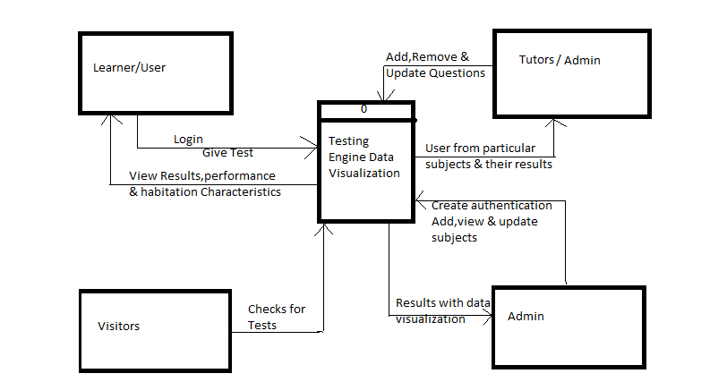

**Use Case Diagrams:**

**Main Use -case Diagram**



**3.4.2 Use -case Diagram for User (student)**



**3.4.3 Use -case Diagram for Admin**



**Database Design:**

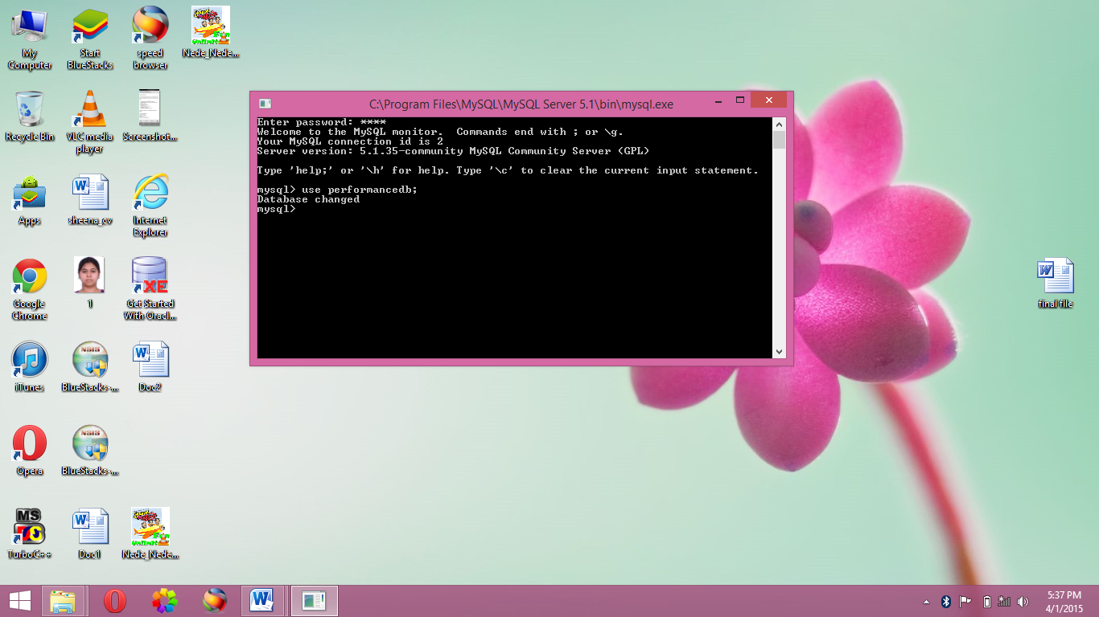

**List of tables in project:**

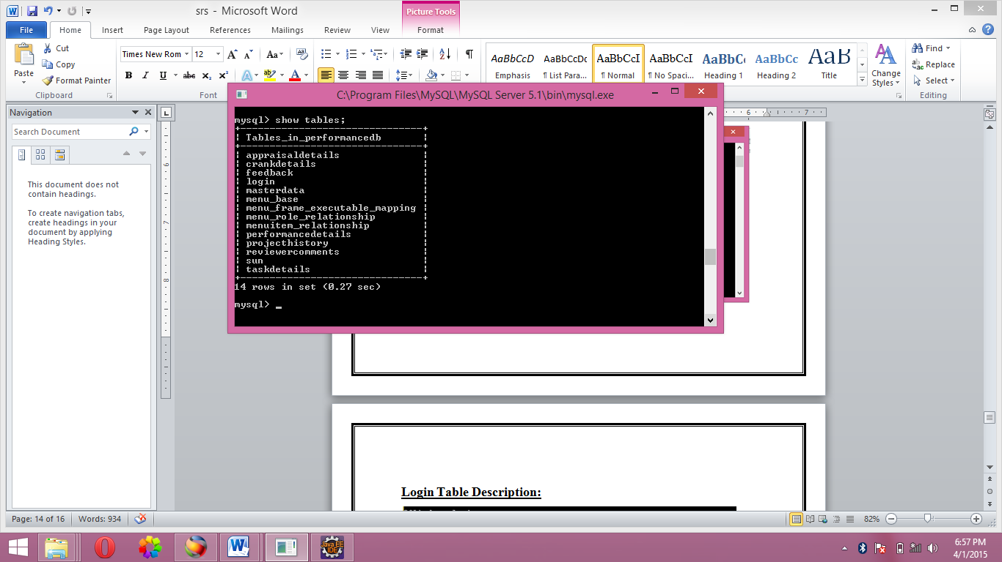

**Login Table Description:**

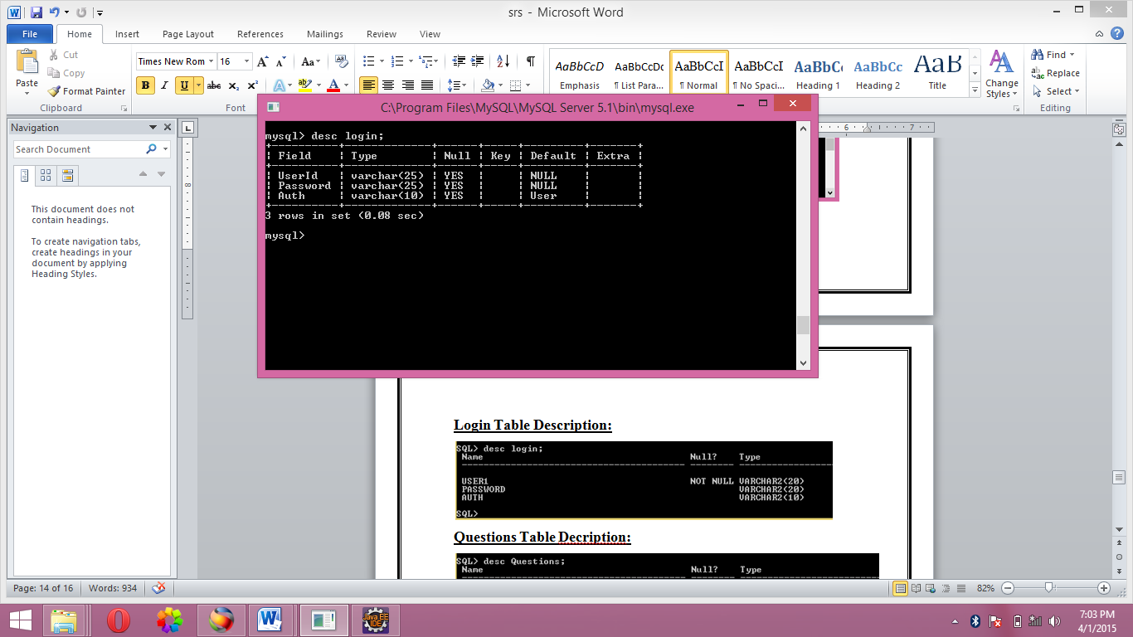

**Appraisal detail Decription:**

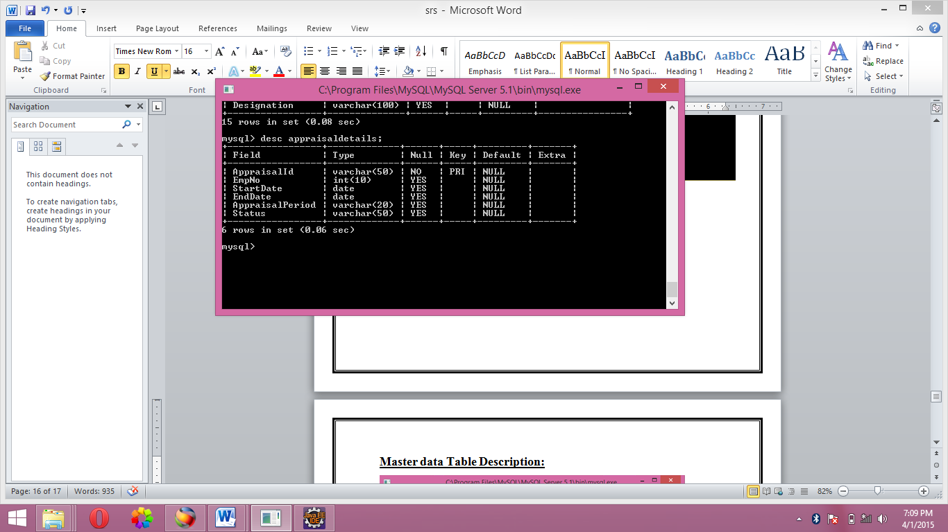

**Master data Table Description:**

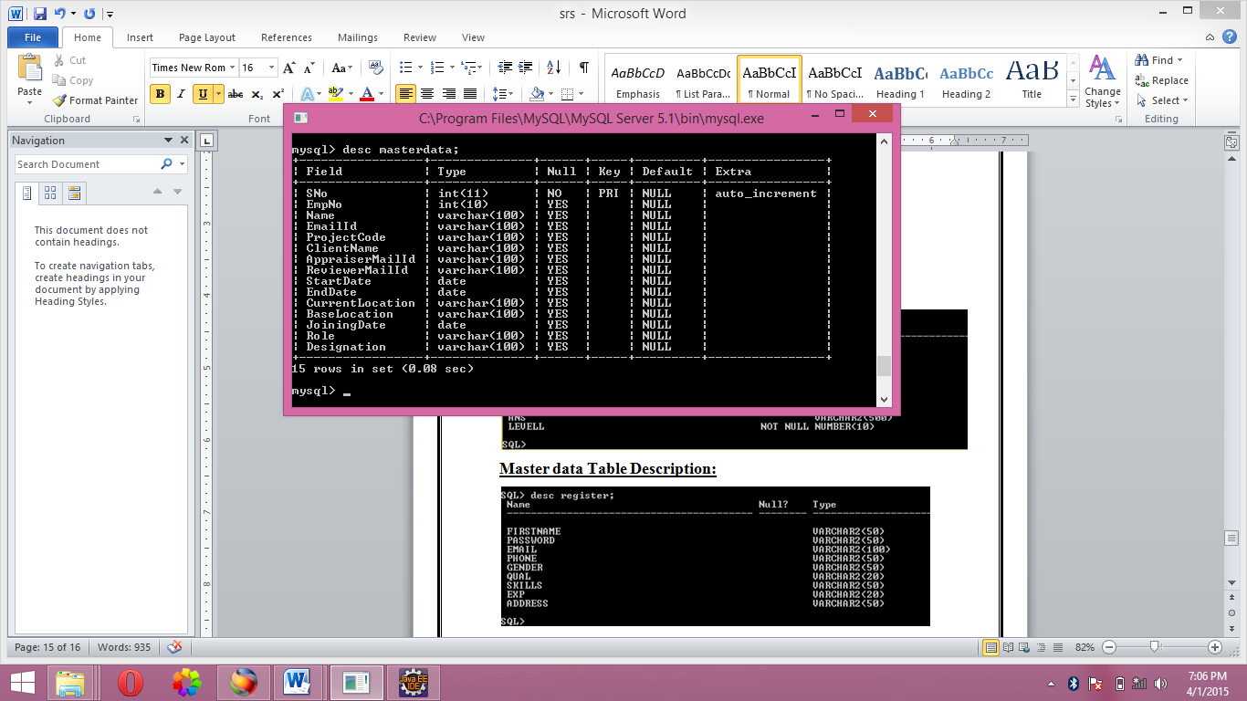

**Feedback Description:**

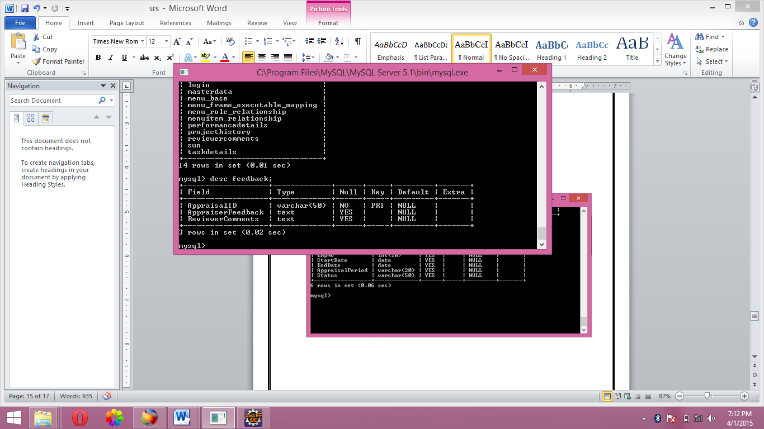

**Reviewer Comment Description:**

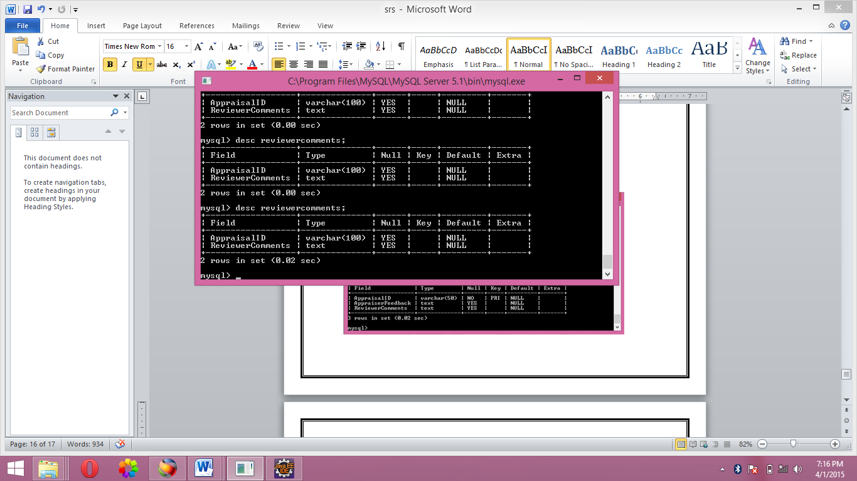

**Current Work:**

**Teacher Module :** Teacher also can add,view,delete the questions. Room activity type validation will be used in this project.

Also I am thinking to shift this project either on struts or hibernate.